RP IPRC MUSANZE

ELECTRICAI AND ELECTRONICS ENGINEERING

ELECTRICAL AUTOMATION TECHNOLOGY

UWITONZE Ange Immaculee

21RP02846

PUBLIC SECURITY BY USING ALCHOL SENSOR

MQ3 is one of the most commonly used sensors in the MQ sensor series. It is a Metal Oxide Semiconductor (MOS) type of sensor. Metal oxide sensors are also known as Chemiresistors, because sensing is based on the change of resistance of the sensing material when exposed to alcohol.

So by placing it in a simple voltage divider network, alcohol concentrations can be detected.

This sensor detects the presence of alcohol in the air as well as its concentration. So, if you want to build your own breathalyzer to determine how much alcohol is in someone’s breath, the MQ3 alcohol sensor module is an excellent choice

Nowadays drinking alcohol and driving are the most common threats to their lives and the lives of others. We can’t stop people from drinking alcohol but we can avoid such accidents by checking the person drinking and we can also keep such small devices in the vehicle to make sure there is no drink and drive.

Also our alcohol detector its can be used in various applications like in schools to detect students who drunk beer in order to prevent some unplanned events, it can also used in some industrial to evaluate if the workers\employees have not drunk.

COMPONENT NEEDED TO ACCOMPLISH WORK

1.ARDUINO UNO BOARD

2. ALCOHOL SENSOR (MQ3)

3. LED

4. BUZZER

5. JUMPER WIRE

6. BREAD BOARD

7. RESISTOR

CIRCUIT DIAGRAM

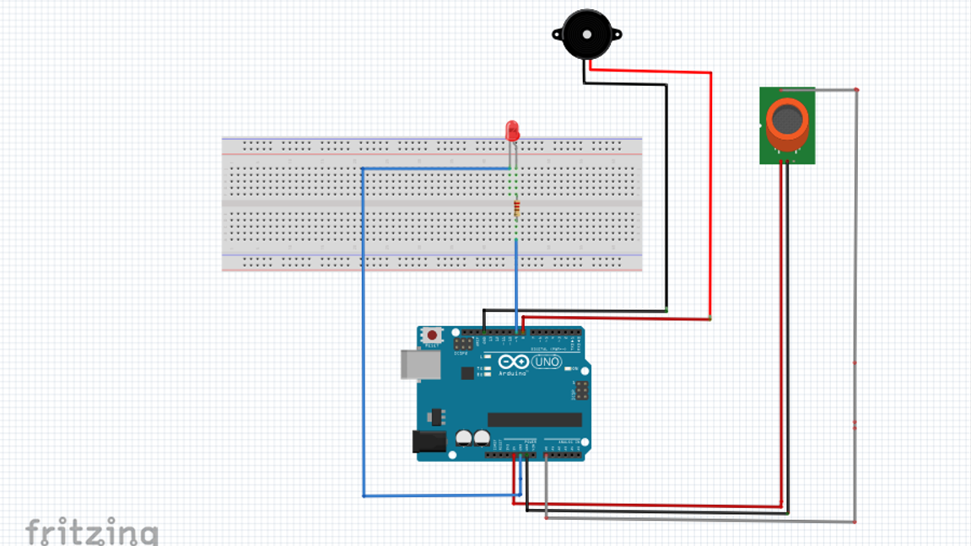

Working principle

In this project I have more materials which will help to complete it, which is; MQ3, BUZZER, LED, JUMPER WIRE, ARDUINO UNO BOARD, BREAD BOARD.

First there is MQ3 as INPUT is connected to analogue pin A0 and its VCC is connected to 5V also its ground port is connected to GND pin of ARDUINO UNO BOARD , second is our BUZZER as OUTPUT is connected to digital pin number 8 (D8) and its ground is connect to ARDINO’S ground (GND) , third is LED as OUTPUT its ANODE is connected to digital pin number 9 (D9)and its CATODE is connected to ground of ARDUINO UNO BOARD.

After this we can connect our ARDUINO UNO BOARD to computer and upload its code above and after do all we can bring beer or any alcohol which will be applicated to our MQ3 sensor , after our sensor will detect presence of an alcohol our BUZZER make noise and LED will blink after 5 second our sensor loose its alcohol will be low and BUZZER and LED will stop to give us any signal.

SOURCE CODE

#define MQ3 A0

#define Buzzer 8

#define LED 9

#define Thres_Val 460

int value;

void setup () {

// declaring the input and output pins

pinMode (MQ3, INPUT);

pinMode (Buzzer, OUTPUT);

pinMode (LED, OUTPUT);

Serial.begin (9600);

}

void loop() {

value = analogRead (MQ3);

Serial.println (value);

if ( value > Thres_Val )

{

digitalWrite ( LED , HIGH );

//digitalWrite (Buzzer,HIGH);

tone(Buzzer, 1000);

}

else {

digitalWrite (LED, LOW);

//digitalWrite (Buzzer,LOW);

noTone (Buzzer);

}

delay (500);

}